Resume
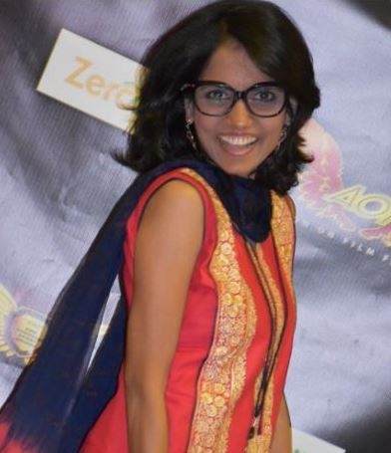 | Name: |  | Pragati Baburao Kolage
 | Email: |  | PragatiKolageMovie@Hotmail.com
 | Contact:
 | Height: |  | 5.1”
 | Weight: |  | 90 lb
 | Union Status: |  | Non-Union
 | Location: |  | Herndon, VA 20171
 | Traveling: |  | Yes
 | Video / Skype Audition: |  | Yes
Achieved Awards for the movie ‘Palyadawasi’ in 2017
Festival Name |  |  |  | Country |  | Award
(1) Alternative Film Festival (ALTFF) |  |  |  | CANADA |  | Best Actress Award
(2) Washington DC South Asian Film Festival (DCSAFF) |  |  |  | USA |  | Best Actress Award
(3) 5th Indian Cine Film Festival-17 |  |  |  | INDIA |  | Best Actress Award
(4) Yosemite International Film Festival |  |  |  | USA |  | Best Actress Award
(5) Hollywood Film Competition |  |  |  | USA |  | Best Female Actor (Platinum Award)
Work Experience
Film:
Film Name |  | Role |  | Year | Director
‘Palyadawasi’ (Full Feature) |  | Lead Actress |  | 2017 | Pragati Kolage
‘The Light Between Us’ (Full Feature) |  | Supporting Role |  | 2019 | Elly Spurs
"Mr. Lickers!" (Student Film) |  | Lead Role |  | 2019 | Kofi Gayle-Tendai
TV:
Program Name |  | Role |  | Year | Director
Bud Appetite (Pilot Episode) |  | Supporting Role |  | 2019 | Lisa Scott
Live Show:
Show Name |  | Role |  | Year | Director
“Tt’s aLive” Neil Patrick Harris’s Facebook Live Show |  | Participant |  | 2019 | Neil Patrick Harris
Commercial:
Project Name |  | Role |  | Year | Director
Hilton Hotel Project |  | Participant |  | 2019 | Brittany Williams
Enchant Christmas Video & Photo shoot |  | Participant |  | 2019 | Chelsea Rooks
Extra / Background
Project Name |  | Role |  | Year | Director
The Good Lord Bird (Episode 5) |  | Background Role |  | 2019

