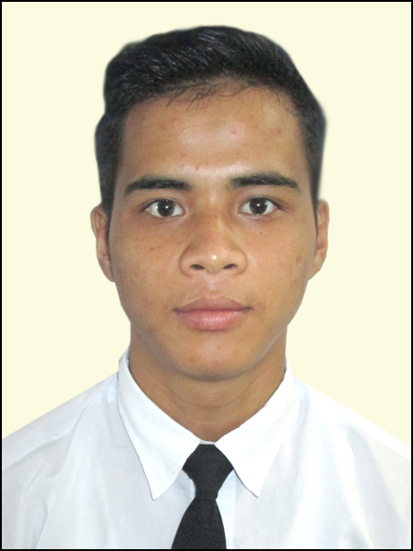
RESUME

Donborroi Marthong
Address : Shangbangla, Ribhoi,Nongpoh
Shillong Meghalaya
Contact No : +91- 9774657194
Email id :meban.marthong@gmail.com

Career Objective:

To associate with a progressive organization that gives me scope to update my knowledge and skills in accordance with latest trends.

Academic Qualification:
Qualification | Board/University | Year of Passing
SSLC | JNV/AISSCE | 2011
HSSLC | JNV/AISSCE | 2013

Professional 12 months Course :
Vocation Trained by Centurion university Technology and Management college for Hospitality and Softskills and communication skills in Shamshabad Hyderabad spooncer by Meghalaya Government... And One years Training for Self Defense and boxing and Karate tip from MMA institutions Nongpoh Ribhoi District Meghalaya State

- Front Office
- Hospitality services
- Acting skills
- Self defense Trained
- IT Skills

Front Office:

- Answering customers calls and guided them by solving their predicaments.
- Receiving and greeting clients politely, leaving a positive impression of the firm
- Check the mails and give the room booking confirmation
- Communicating customer related to the property and Local city information
- Assisted in managing inventory of office supplies
- Handling paperwork and filing duties

:Hospitality service.

- Professional work ethics
- Trained for Multi tasks in different customers Service areas
- Excellent written and verbal communication skills
- Ability to work in a team
- Ability to take orders
- Sales and marketing skills
- Customer service skills

Professional experience :2 Khasi local language flim experience...
Role: villain
(1) Fighter ( Karate: U.F.C fighter)
(2) Emotional action
(3) Stylish action with propped Dress

Computer Knowledge:
- Trained on MS Word, MS Excel and presentations on MS PowerPoint
- Capable of browsing the internet through different browsers like, Internet Explorer, Mozilla Firefox and Google Chrome

Specialization Training:
- Boxing and MMA training
- Personality Self defense programme specialized trainer
- Communication Skills
- Spoken English

Personal Skills:
- Hard working and Positive Attitude,Patience
- Zeal to learn new things
- Readiness of change to the environment

Achievements:
- I was the leader for from 07th to 10th class during my schooling.
-Awarded as best player with Boxing fight competition .

Hobbies : Action with mobile camera ,karate practice , boxing playing
Personal Profile:
=Name : Donborroi Mathong
=Fathers Name :Mar Shal Marwein
=Date of Birth :15th.Feb.1994
=Sex :Male
=Nationality :Indian
=Hair colour.Black :Eyes color Black
=Marital Status :Single
=Languages known :English,Hindi & Khasi
= Height 5.3inch. : Weight 55kg
Declaration:I here by declare the above-mentioned information is true and fair as per the best of my knowledge and belief.

Date: PLACE: Shillong

Donborroi Mathong

