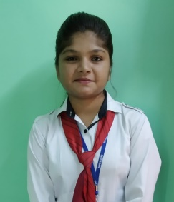
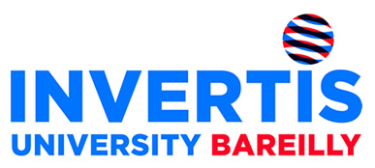
Name: Nishu Yadav
Email id: nishu3301@gmail.com
Contact: 8933975372

CAREER OBJECTIVE

To secure a responsible career opportunity to fully utilize my professional qualification, training and skills, while making a significant contribution to the success of the company.
ACADEMIC QUALIFICATION

Name of the Examination | Name of the Institute | Board/University | Year | Percentage
MCA | Invertis University, Bareilly | Invertis University, Bareilly | Pursuing  (2018-2020) | 58%  (agg.)
BCA | Invertis University, Bareilly | Invertis University, Bareilly | 2018 | 57%
Senior Secondary | Azad inter college RAMPUR FATTEPUR GHAZIPUR | UP Board | 2015 | 71.6%
Secondary | SUMITRA MODERN SCH VIJAY LAXMI NGR SITAPUR | CBSE | 2011 | 52%

SUMMER TRAINING
LIVE PROJECT

Name of organization: SD Web Solution,
Key Take Away: ASP .net, SQL server

CERTIFICATE PROGRAMME/ WORKSHOPS/CONFERENCES

- Attended International Seminar ACT (Advanced Computing Technologies) in 2018 held in Invertis University
- Attended one day workshop on Python,Bigdata,Android conducted by APTRON Solutions Pvt. Ltd in Invertis University
- Attended one day workshop on Cyber Security Awareness program in 2016 coducted by INNOVATIVE IDEAS INFOTECH

- Volunteer in University fests.
ACHIEVEMENTS
- Certified by SD Web Solution in website development.
- Certified by Advent Softech India in Android.
- Certified by APTRON Solutions Pvt. Ltd in Bigdata.
- Certified by APTRON Solutions Pvt. Ltd in Python.
- Certified by APTRON Solutions Pvt. Ltd in Android.
- Certified by Google in Digital Marketing.
- Certified by innovative ideas infotech in cyber security
KEY ATTRIBUTES
- Easy in adapting things.
- Quick Learner.
- Creative.

- Communication Skills
- Managing Events
INTEREST

- Languages :- ASP .net, SQL server, PHP , HTML
- Testing and resolving errors.
PERSONAL PROFILE
- Easy in adapting things.
- Quick Learner.
- Creative.
DETAILS

Date of Birth : April 1th 1997
Father’s Name : Mr. Pradeep Kumar Yadav
Mother’s Name : Mrs. Renu Yadav
Gender : Female
Language : English, Hindi
Address : Buddha nagar hussain ganj ,sitapur(261001)
DECLARATION
- Easy in adapting things.
- Quick Learner.
- Creative.
DETAILS

I hereby declare that the information provided above is true and the best of my knowledge.

Date:31/08/2019 Signature: Nishu

