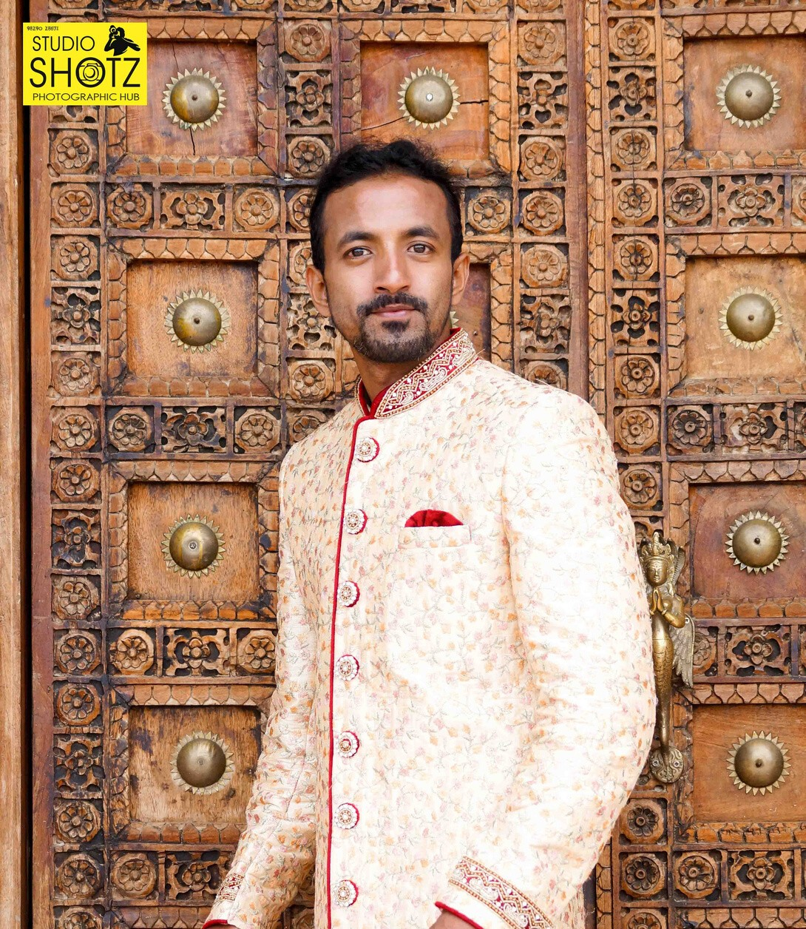Amals Jose
Bengaluru

Height: 5.7 | Weight: 58kg | Chest: 37 | Hip:27 Skin Color: White | Body type: Slim & Fit | Eye color: Black

Krishna Reddy apartment RS Tower, Room no:S2 GS Palaya road Konappana Agrahara E.city Phase2 Bangalore Karnataka 560100
Mob: +91 78995 26634 | Email: amalsjs1@gmail.com

GOALS

To be an established model ( print and commercial) and make a positive impact on a large number of people.
To be a fame, model in commercial ads.

achievement

Over- all Performer Award Winner - Mr India Super Model Hunt - Season 3 , Aura and Dream Productions ( Jaipur, Sept 2019 )
Experience

I had been trained by the famous Groomer Rita Gangwani ( Miss World- Manushi Chillar), International Choreographer Babla Kuthiriya and Varun Katial ( Mr India groomer) through the 10 day programme
at Jaipur. The knowledge obtained during those sessions is immense, which motivates me to explore more in this domain.

Shoot Experience

Casual shoot, ethenic wear shoot, gym wear shoot, swim wear shoot.

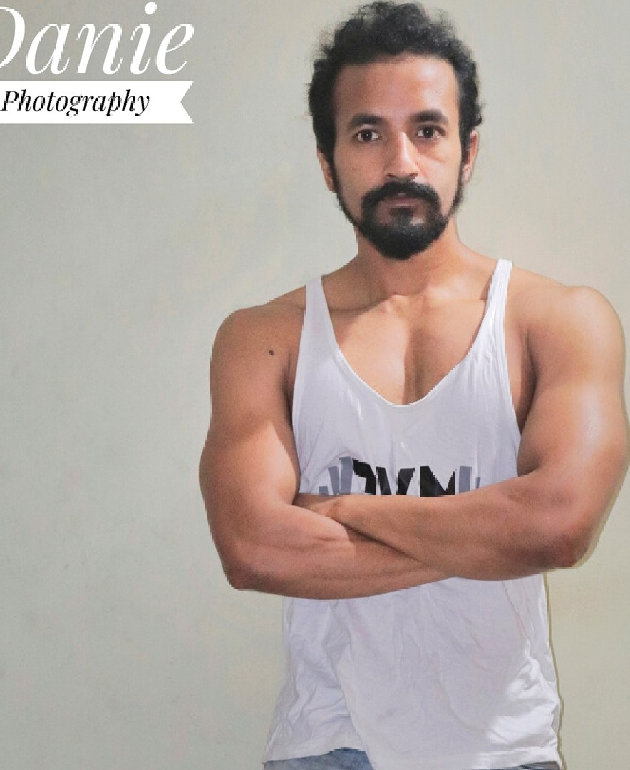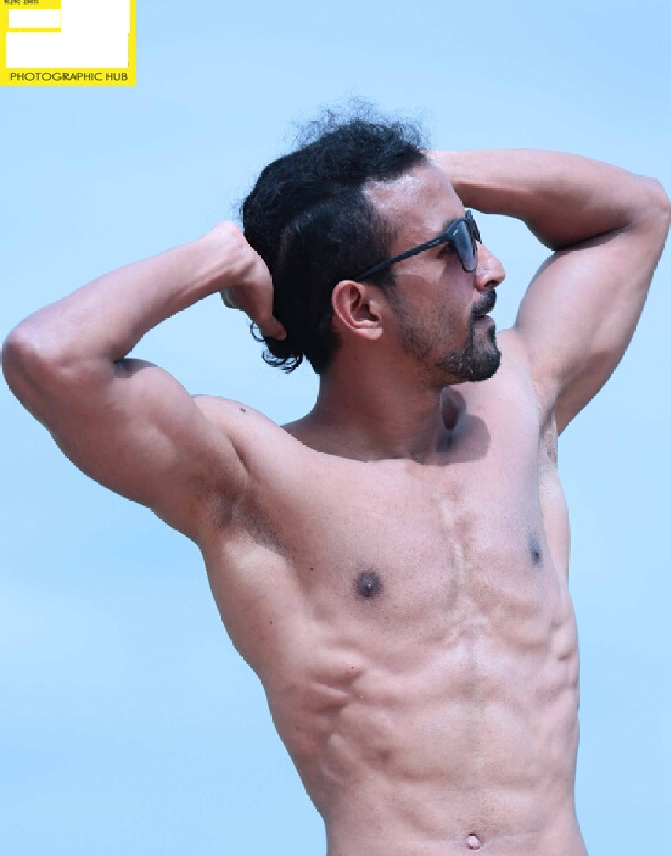
SH@TZ
sTuDio
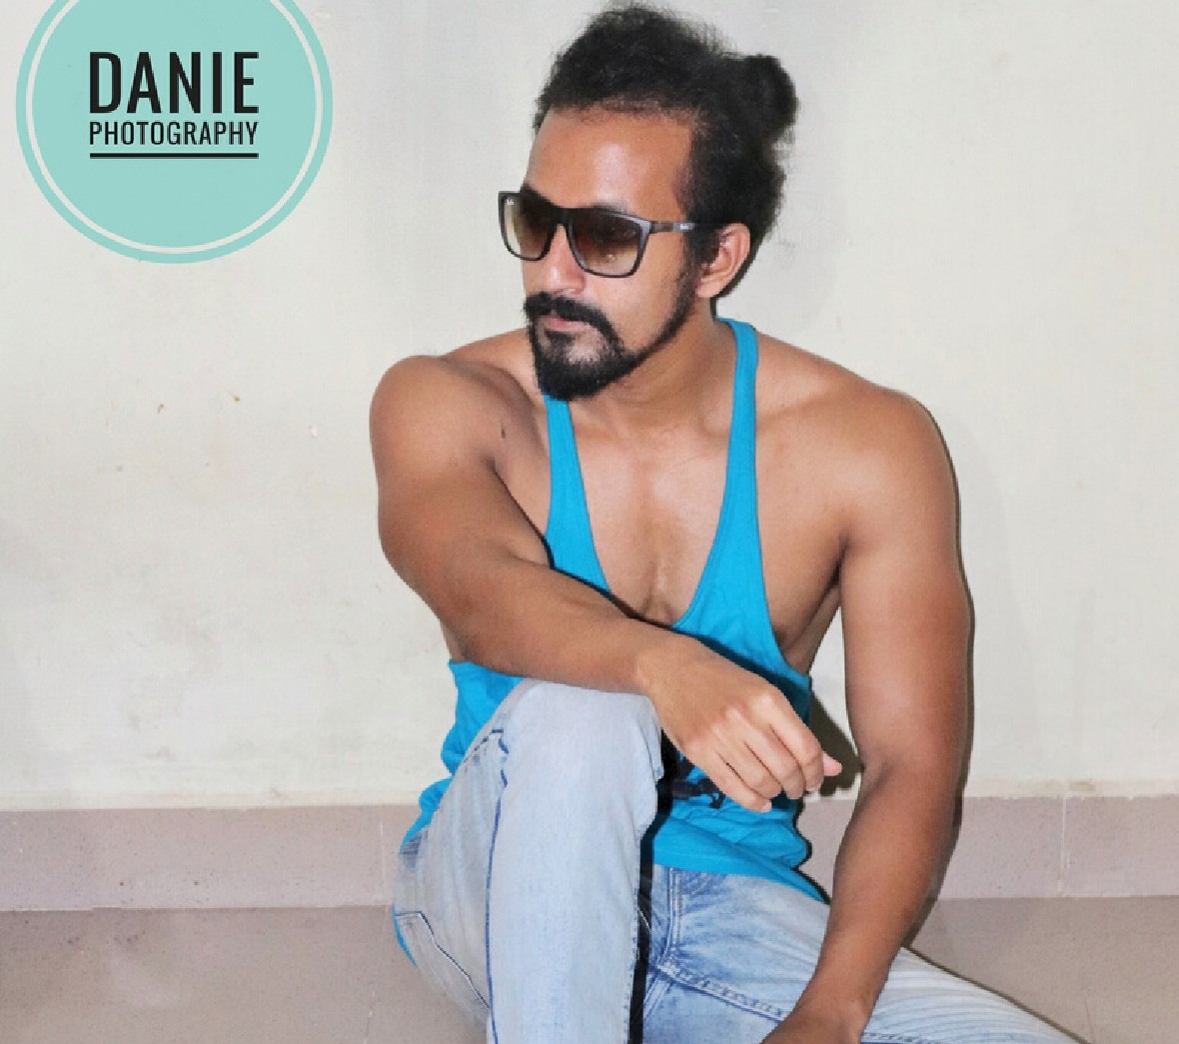
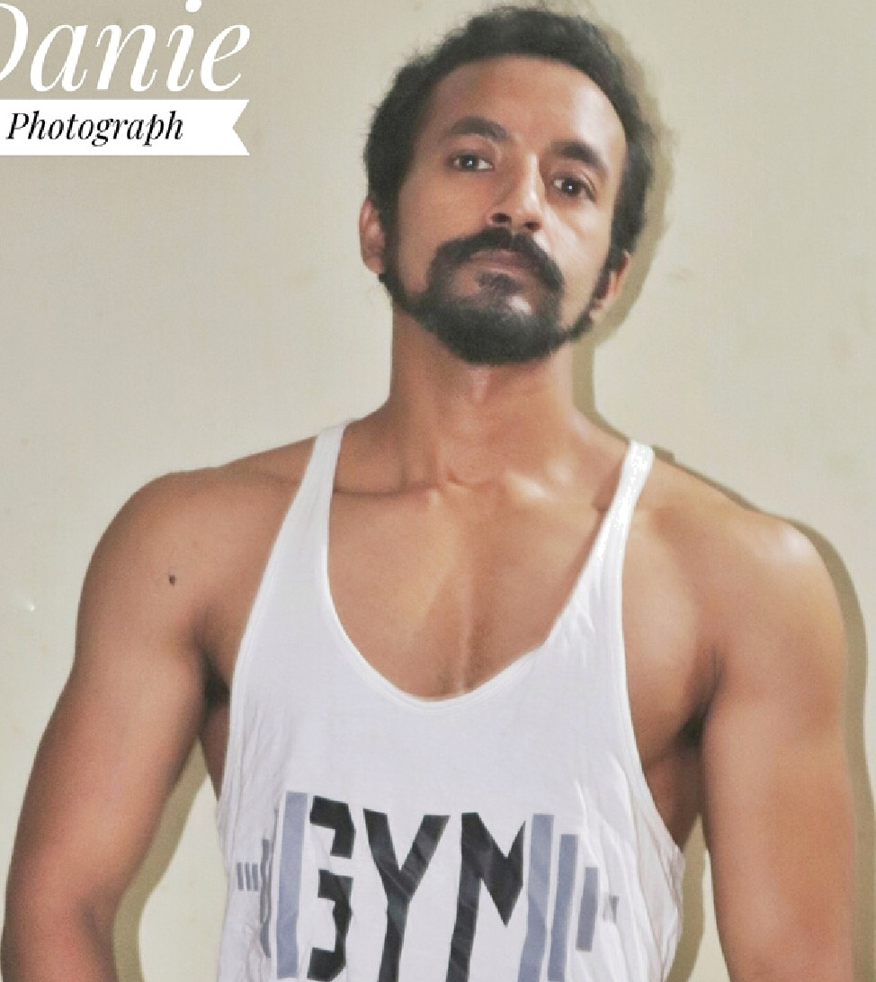
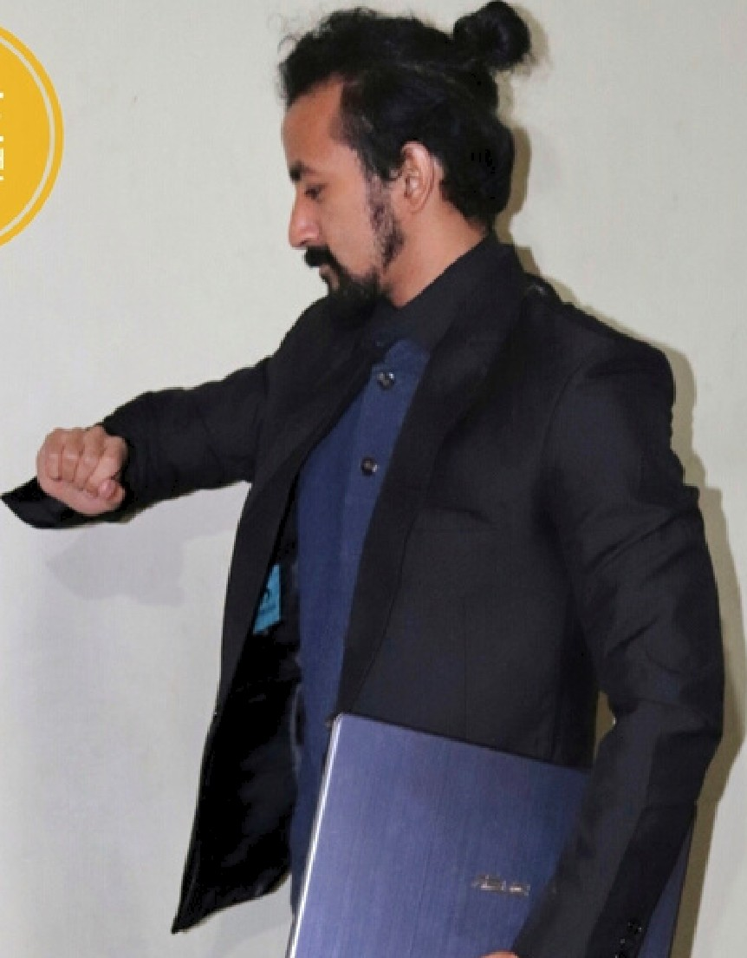
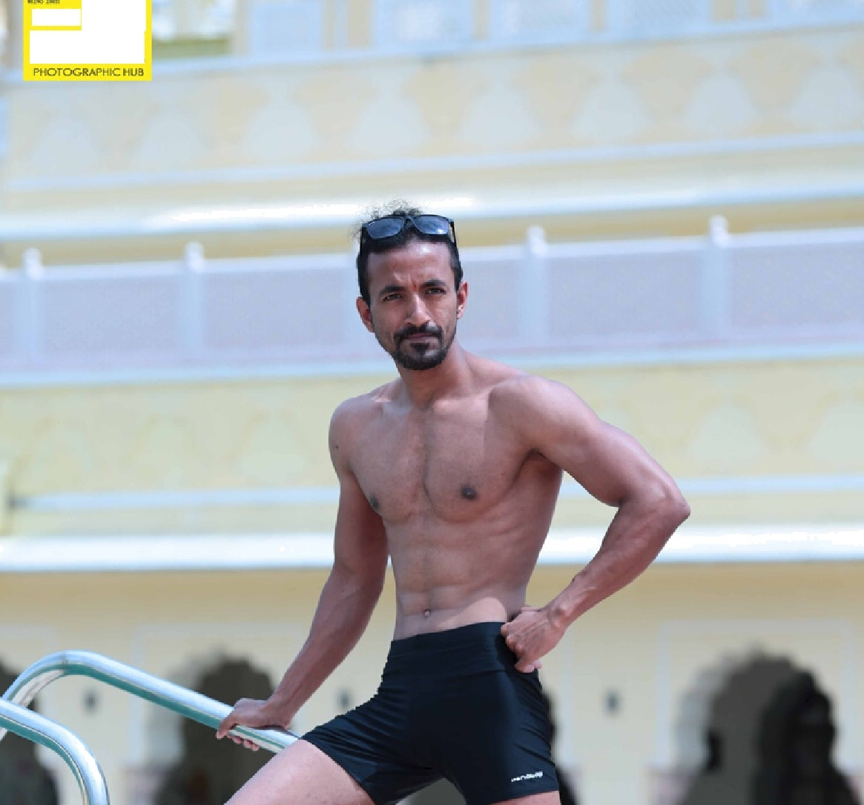
SH@TZ
sTuDio

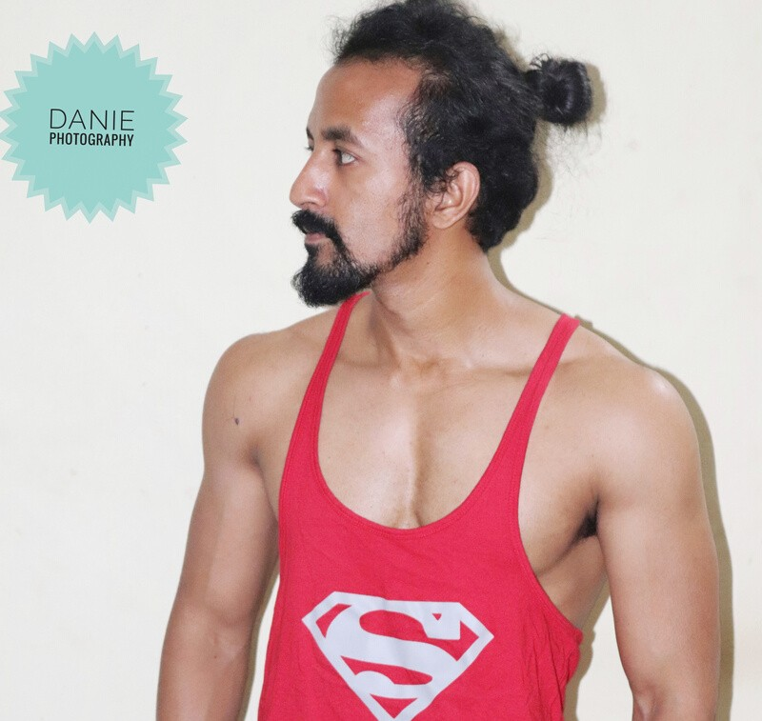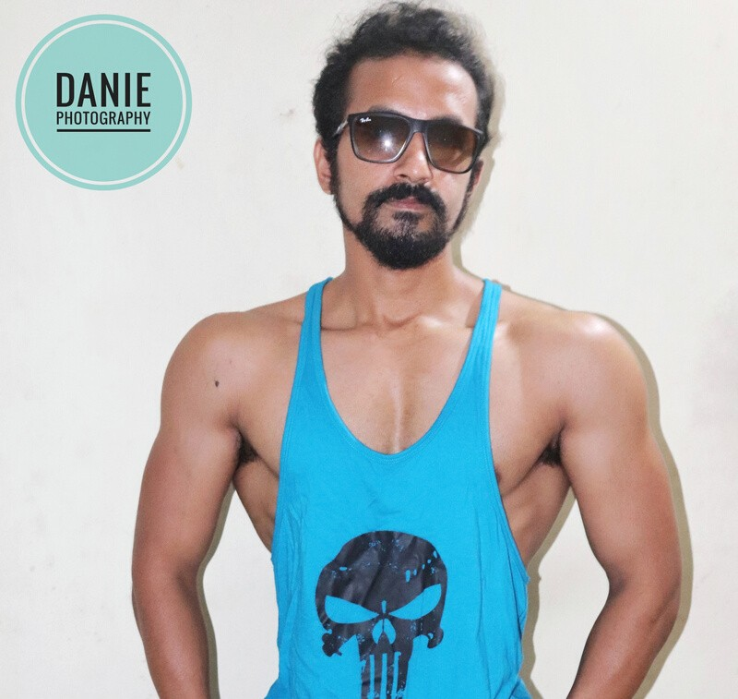
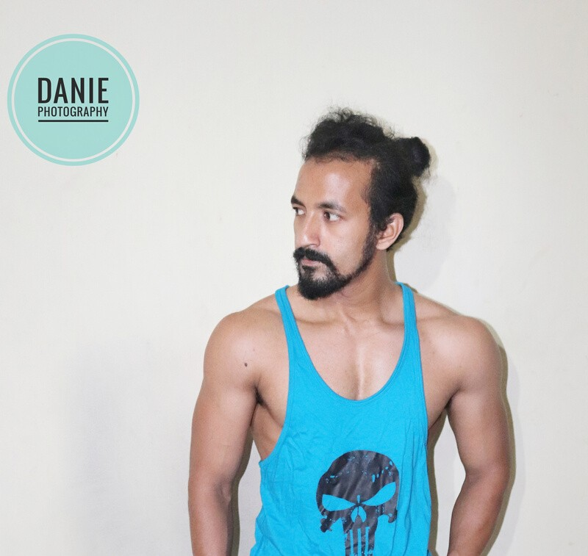
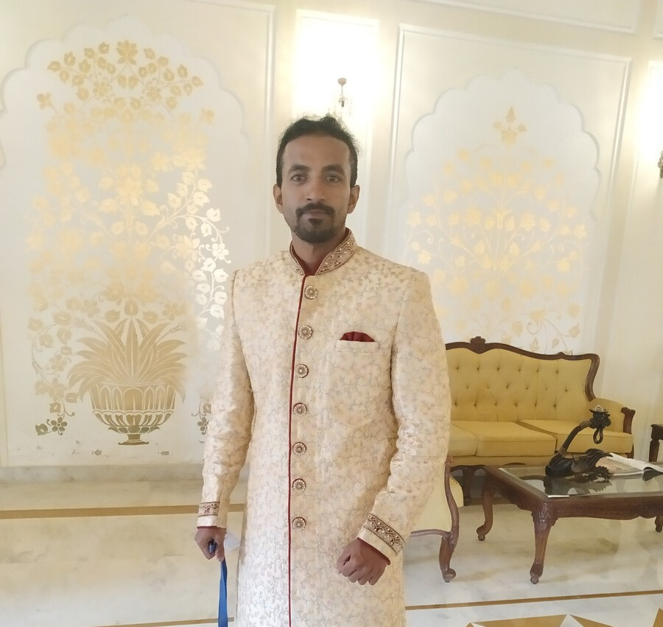
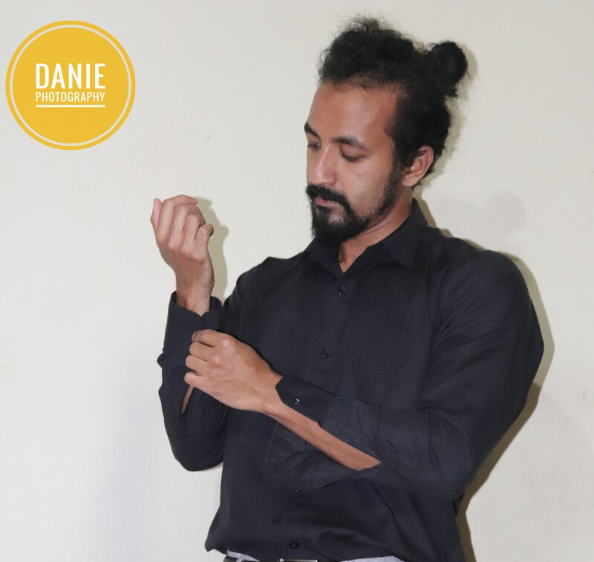
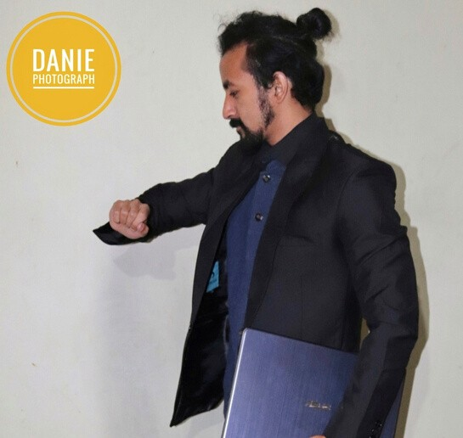

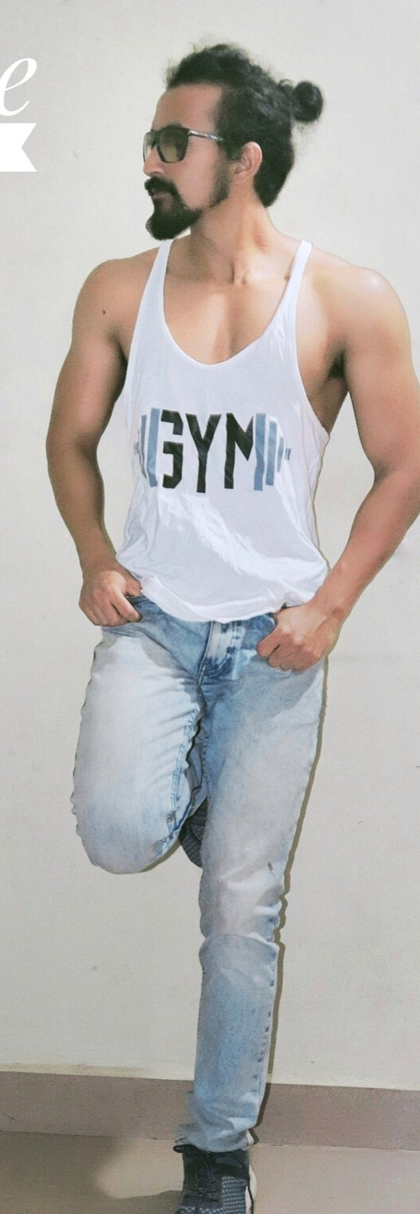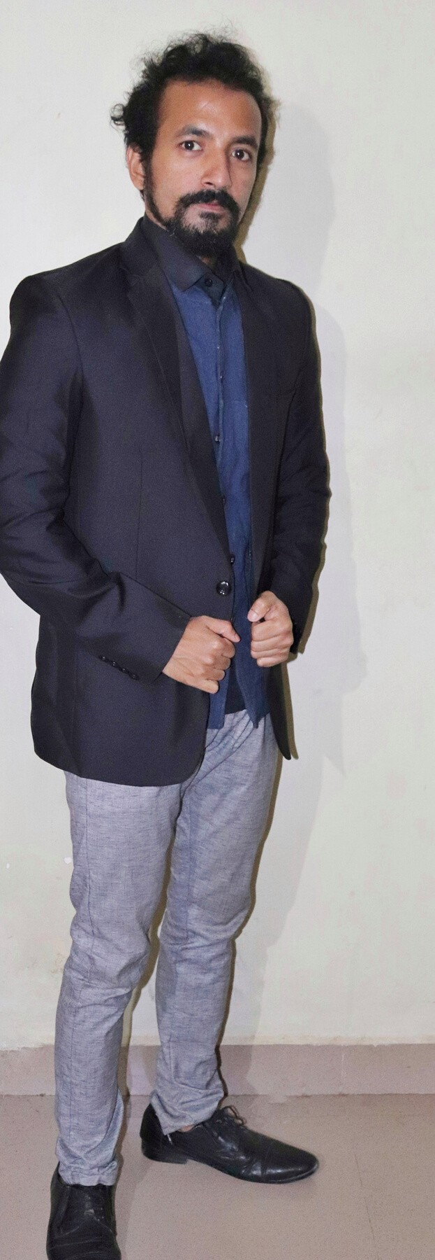

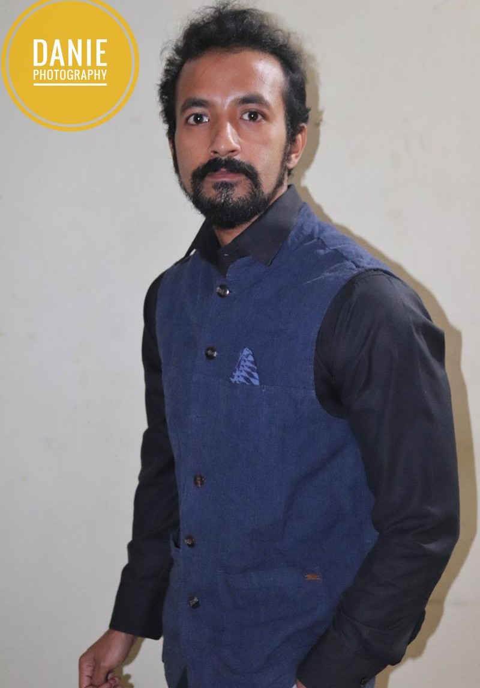
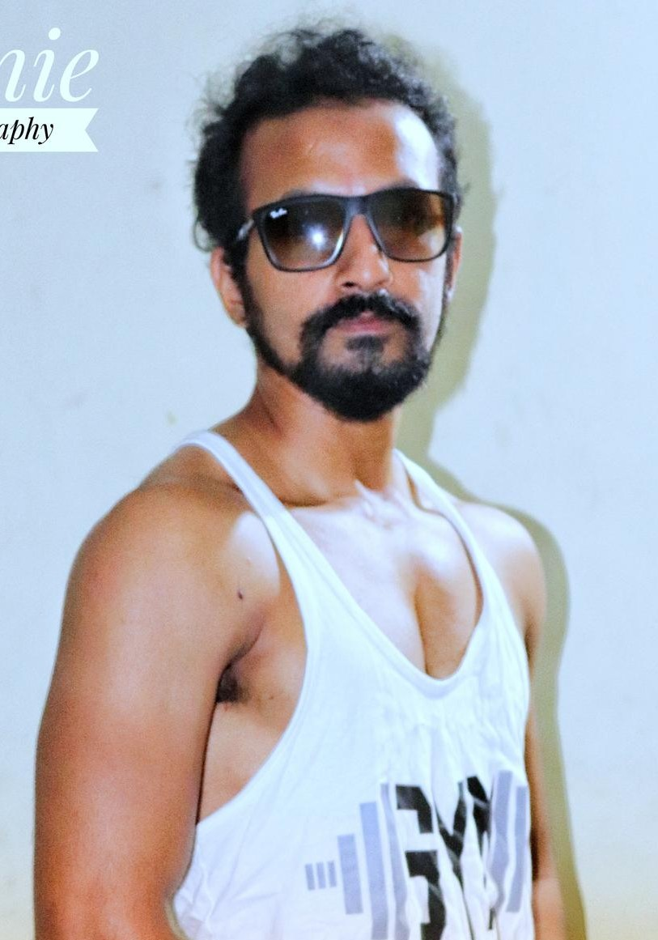
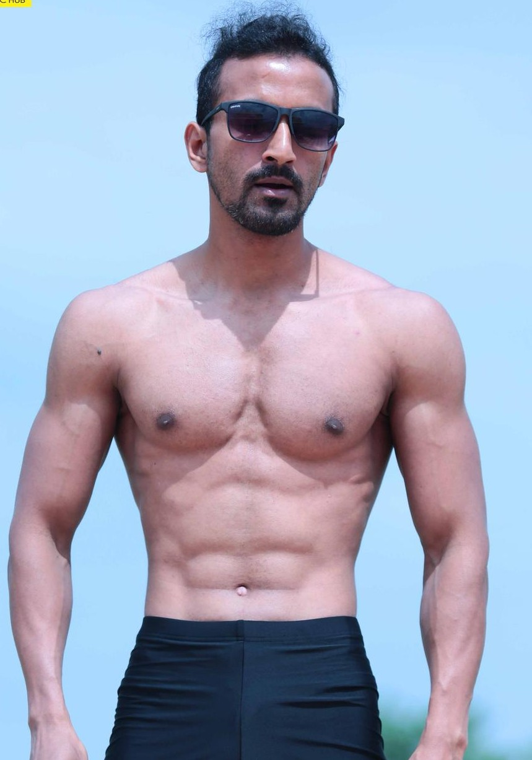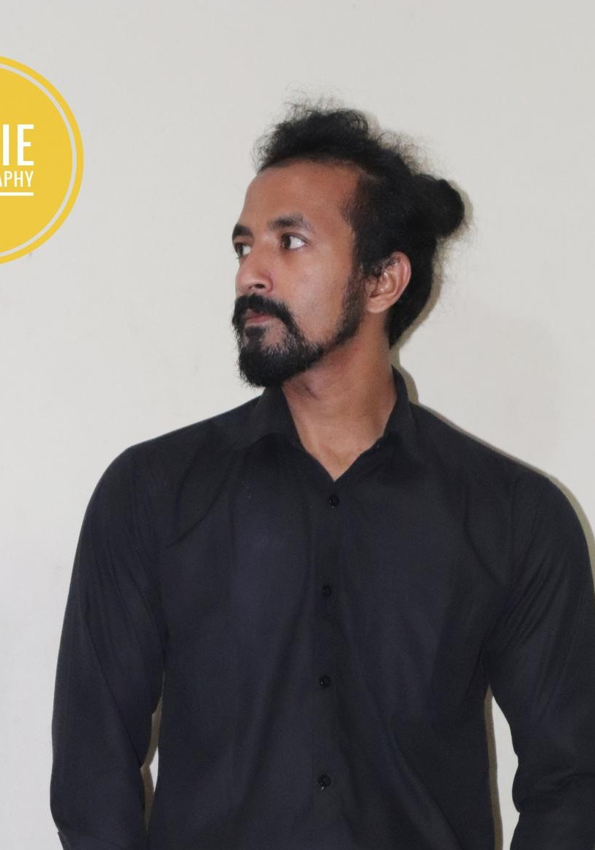

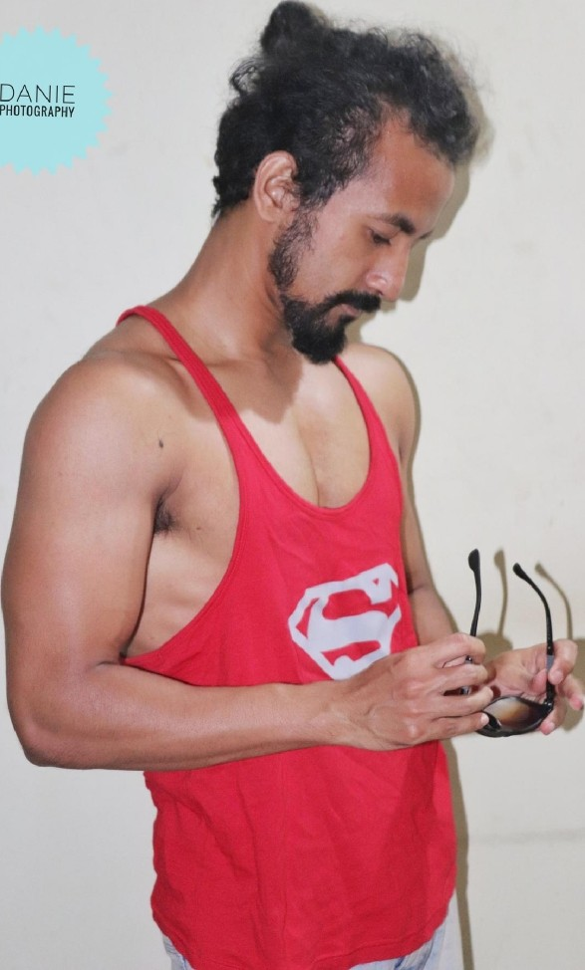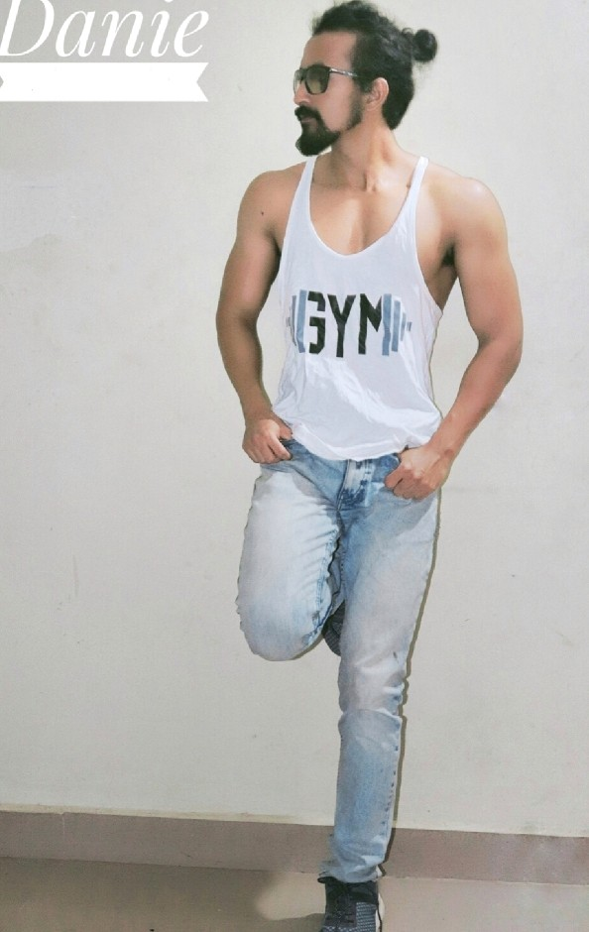
Photography

